Report No.  报告编号： | ISP2020**** |  | Inspection date  验货日期： |  |  |  |  | 10-Jan-2015
Report issuing date  报告日期： | 12-Jan-2015 |  | Contract No.  合同号：
contact name  业务员： |  |  | Names of inspectors  验货员：
Kind of Inspection  验货类型： | On Line / FRI  线上 / 尾查 |  | INSPECTION  验货次数 |  |  |  |  | 1
供应商 Supplier
地址 Factory adress :
品名 Item designation |  |  |  |  |  |  | 有机棉: YES NO
货号 Item reference
现场抽取测试样数量 :  N°of samples on testing | N/A |  | 现场抽取船样数量:  Nbr of sample picked for pre-shipment testing |  |  |  |  |  | N/A
综合结论/General Inspection Result |  |  | Conform |  | Not Conform | Reservation |  |  | Remark
大货生产数量是否相符：
Presented quantity :
款式/材质/颜色是否相符 :
Style, material and color conformity
做工是否相符：
Workmanship
包装是否相符 :
Product packaging
标签是否相符:
Packing & Label
唛头是否相符 :
Shipping Marking
尺寸是否相符:
Data measurement
综合结论CONCLUSION GENERALE INSPECTION : NOT CONFORM
结论评语Comments :

验货员签字： |  |  |  | 供应商签字：
查货样 / Reference sample
有否查货样  Availability |  | Yes |  | 客户批办  业务批办  供应商自留办
 |  |  |  | 是否完整包装/ With complete consumer packing
 |  | No |  | 无查货样原因 / reason if No :
验货完成后查货样处理  Storage after inspection |  | 供应商封存备用 |  | 公司业务封存  公司品管封存  公司总经办备用
生产工艺单 / Technical file
来源/ received from |  | 业务 供应商 无

验货标准: INSPECTION METHOD
Acceptable (AQL) pour : Critique: 0 / Majeur (Major) : 1.5 / Mineur (minor) : 4.0
抽查总数Sampling size : | 200PCS
每个尺码抽5件查尺寸  Measurements checked on 5 pieces per size minimum | 30PCS
抽查箱号记录/ Samples selected from carton numbers:
颜色. | Carton No.箱号 | 颜色. | Carton No.箱号
028201 | 5, 23, 16, 9, 31, 5 / 2, 8, 13 | 028301 | 7, 35, 16, 22, 43, 53, 64, 8 / 13
028202 | 4 / 1 | 028302 | 1 / 1
028203 | 2 / 5 | 028303 | 13, 6 / 3
028204 | 4 / 5 | 028304 | 7 / 3
028205 | 6 / 1 | 028305 | 2, 12 / 2
产品查验结果/ PRODUCT CONFORMITY :
 | 相符/ Conform | 不相符 /Not conform | 无查货样 / No reference sample
款式(Style conformity) :
材质Material conformity :
颜色color conformity
做工品质 / WORKMANSHIP APPEARANCE – FUNCTION
问题点记录  Observation and remarks |  |  |  |  |  | 不符点数量Number of defects
 |  |  |  |  |  | C | M |  | m
For LEC 028201 Sample size=84pcs |  |  |  |  |  | 0 | 0 |  | 0
Pleat on leg opening |  |  |  |  |  | 0 | 3 |  | 0
dirty stian slightly on inside |  |  |  |  |  | 0 | 0 |  | 10
Untrimmed thread ends (2cm) on neck/leg opening |  |  |  |  |  | 0 | 0 |  | 3
Dirty stian obviouly on inside |  |  |  |  |  | 0 | 2 |  | 0
Dirty stian obviously on in side (also found pleat on leg opening) |  |  |  |  |  | 0 | 1 |  | 0
Broken stitches (2cm) on neck |  |  |  |  |  | 0 | 1 |  | 0
Untrimmed thread ends (2cm) on neck |  |  |  |  |  | 0 | 0 |  | 1
For LEC 028303 Sample size=7pcs |  |  |  |  |  | 0 | 0 |  | 0
For LEC 028305 Sample size=8pcs |  |  |  |  |  | 0 | 0 |  | 0
Dirty slightly on inside |  |  |  |  |  | 0 | 0 |  | 2
C : 严重 / critical defect  M : 主要/ Major defect  m : 次要/ minor defect |  |  |  | TOTAL |  | 0 | 17 |  | 33
概述 | Critical |  | Major |  |  | Minor
AQL : 0/ 1.5/ 4.0 | accepted | Refused | Accepted |  | Refused | Accepted |  | Refused
标准 Limits : | 0 | 1 | 7 |  | 8 | 14 |  | 15
结果 Seen : | 0 |  | 17 |  |  | 33

包装及标贴  PACKING AND LABELS | 是否正确  Conforme |  |  |  | 问题描述  DESCRIPTION
唛头Shipping mark conformity: | Yes | No | Reservation | N/A
侧唛Side mark conformity: | Yes | No | Reservation | N/A
标贴Label and brand tag | Yes | No | Reservation | N/A
位置Position | Yes | No | Reservation | N/A
洗水标内容  Care label code/symbol (LOGO) | Yes No Reservation N/A
洗水标位置  Position of care label | Yes No Reservation N/A
洗标成份是否正确  Composition according regulation | Yes No Reservation N/A
包装袋印刷内容  是否正确Polybag printing | Yes No Reservation N/A
内盒印刷内容是否正确  Inner box printing | Yes No Reservation N/A
其它标签是否正确  Other labels (carton label) | Yes No Reservation N/A
衣架包装方式是否正确  product on hanger | Yes No Reservation N/A
装箱配比是否正确  Order packaging / assortment (lots) | Yes No Reservation N/A
箱规尺寸是否正确  Size distribution | Yes No Reservation N/A
CARTON D’EMBALLAGE / Packing carton
包装 / Packing
产品包装 / Marking on product
是否有产品条码 EAN-13 | YES NO
条码是否可读  Product EAN-13 barcode readable with scanner (photo) | YES | NO | No. on scanner: |  | 3607709157225
 |  |  | Grade : A
条码尺寸是否正确  EAN 13 bar code dimensions | YES | NO
包装袋是否印环保标  Presence of the Pictogram Eco-logo (printed on the  consumer packing / sales packages) | YES | NO | N/A
水洗标内容是否正确  Washing Label | YES NO N/A
吊牌内容是否正确  Hangtag | YES NO N/A
内盒及外箱 / Inner and Export Carton
是否新纸箱（非翻改箱）  New carton (not reused) |  |  |  |  |  | YES NO
纸箱保护完好（未鼓涨未塌陷）  Products are protected and wedged |  |  |  |  |  | YES NO
内箱贴条码是否可读/  EAN-128 (Inner) code system and readable with scanner (photo) |  |  |  |  |  | YES NO  N/A |  |  |  | No. on scanner:
 |  |  |  |  |  |  |  |  |  | Grade : .
箱贴位置是否正确  Barcode conformity on the 4 sides of Master carton EAN128 |  |  |  |  |  | YES NO |  |  |  | Conforme Non Conforme
4.2.6 外箱条码是否可读 /  EAN-128 (Master) code system and readable with scanner (photo) |  |  |  |  |  | YES NO N/A |  |  |  | No. on scanner: 3660941683341,  3660941683396,  3660941683358,  3660941683402,
 |  |  |  |  |  |  |  |  |  | Grade : A
外箱贴尺寸  Bar code dimensions |  |  |  |  |  | YES NO / found: 50 x 36mm  N/A
外箱环保标  Pictogram Eco-logo must be printed on carton |  |  |  |  |  | YES NO N/A
每个箱规抽查五箱, Measurement on 5 cartons
 |  | Cartons | 1 | 2 |  |  | 3 |  |  |  | 4 |  | 5
 |  | 单位 / unit : cm
 |  | 长 / lenght
 |  | 宽 / width
 |  | 高/height
 |  | 单位/unit: kg
 |  | 毛重/ Gross Weight
 |  | 净重 /Net Weight
 | 纸箱跌落测式（6面4角，1米高跌落）  Carton Drop test |  |  |  | 供应商是否拒绝测试 YES No  Factory refuses to do it
 | 1 独立内包装 / 1 consumer packing |  |  |  | Pass |  |  | Fail | Pending |  |  | N/A
 | 1内箱 / 1 inner carton |  |  |  | Pass |  |  | Fail | Pending |  |  | N/A
 | 1 外箱/1 outer carton |  |  |  | Pass |  |  | Fail | Pending |  |  | N/A
 | 1 拖盘 / 1 box pallet |  |  |  | Pass |  |  | Fail | Pending |  |  | N/A
Mesures/ Size measurement check on 30 pcs (unit: cm )5 pcs/size tolerance beyond tolerance
Measurements | 公差 | 尺码/Size : 36 |  |  |  |  |  |  |  |  |  |  |  | 尺码/Size : 38
 |  | 尺寸表 |  | 抽查结果 |  |  |  |  |  |  |  |  |  | 尺寸表 | 抽查结果
CENTER FRONT LENGTH | +/-0.5 | 55.5 |  | +0.5 |  | +1 |  | / |  | +1 |  | +0.5 |  | 57.3 | +1 | / |  | +0.5 |  | +0.5 |  | +1
CNETER BACK LENGTH | +/-0.5 | 31.5 |  | -1 |  | +0.5 |  | +0.5 |  | / |  | / |  | 32.6 | -1 | -1 |  | / |  | +0.5 |  | /
1/2 CHEST | +/-0.5 | 33 |  | / |  | -0.5 |  | +0.5 |  | / |  | -0.5 |  | 35 | / | / |  | +0.5 |  | +0.5 |  | +0.5
1/2 WAIST | +/-0.5 | 29 |  | -0.5 |  | +0.5 |  | / |  | -0.5 |  | +0.5 |  | 31 | +0.5 | / |  | / |  | +0.5 |  | /
1/2 HIP | +/-0.5 | 33 |  | / |  | / |  | +0.5 |  | +0.5 |  | / |  | 35 | / | +0.5 |  | +0.5 |  | / |  | +0.5
FRONT NECK WIDTH | +/-0.5 | 18.5 |  | / |  | +0.5 |  | / |  | / |  | +0.5 |  | 19.5 | -0.5 | / |  | / |  | +0.5 |  | /
ARMHOLE | +/-0.5 | 10.6 |  | / |  | +0.5 |  | +0.5 |  | / |  | -0.5 |  | 11.2 | / | +0.5 |  | +0.5 |  | / |  | -0.5
1/2 LEG | +/-0.5 | 24.7 |  | +0.5 |  | / |  | / |  | +0.5 |  | / |  | 26 | +0.5 | / |  | +0.5 |  | +0.5 |  | +0.5
GUESS | -0/+0.5 |  | 8 |  | / |  | -0.5 |  | +0.5 |  | / |  | / | 8 | -0.5 |  | -0.5 |  | / |  | / |  | /
SHOULDER STRAP LENGTH | +/-0.5 |  | 31.5 |  | -0.5 |  | / |  | +0.5 |  | -0.5 |  | +0.5 | 32 | +0.5 |  | / |  | +0.5 |  | +0.5 |  | /
Measurements | 公差 | 尺码/Size : 42 |  |  |  |  |  |  |  |  |  |  |  | 尺码/Size :44
 |  | 尺寸表 |  | 抽查结果 |  |  |  |  |  |  |  |  |  | 尺寸表 | 抽查结果
CENTER FRONT LENGTH | +/-0.5 |  | 60.9 |  | / |  | +1 |  | / |  | -0.5 |  | +1 | 62.7 | +0.5 |  | / |  | +0.5 |  | +1 |  | +0.5
CNETER BACK LENGTH | +/-0.5 |  | 34.8 |  | -1 |  | / |  | -0.5 |  | -1 |  | +0.5 | 35.9 | / |  | -0.5 |  | -1 |  | +0.5 |  | /
1/2 CHEST | +/-0.5 |  | 39 |  | -0.5 |  | / |  | +0.5 |  | / |  | +0.5 | 41 | +0.5 |  | -0.5 |  | -0.5 |  | / |  | +0.5
1/2 WAIST | +/-0.5 |  | 35 |  | / |  | / |  | +0.5 |  | +0.5 |  | / | 37 | -0.5 |  | / |  | -0.5 |  | / |  | -0.5
1/2 HIP | +/-0.5 |  | 33 |  | / |  | / |  | +0.5 |  | +0.5 |  | / | 35 | / |  | +0.5 |  | +0.5 |  | / |  | +0.5
FRONT NECK WIDTH | +/-0.5 |  | 18.5 |  | / |  | +0.5 |  | / |  | / |  | +0.5 | 19.5 | -0.5 |  | / |  | / |  | +0.5 |  | /
ARMHOLE | +/-0.5 |  | 10.6 |  | / |  | +0.5 |  | +0.5 |  | / |  | -0.5 | 11.2 | / |  | +0.5 |  | +0.5 |  | / |  | -0.5
1/2 LEG | +/-0.5 |  | 24.7 |  | +0.5 |  | / |  | / |  | +0.5 |  | / | 26 | +0.5 |  | / |  | +0.5 |  | +0.5 |  | +0.5
GUESS | -0/+0.5 |  | 8 |  | / |  | -0.5 |  | +0.5 |  | / |  | / | 8 | -0.5 |  | -0.5 |  | / |  | / |  | /

问题点图示 / Any other markings DEFAUTS / Defects
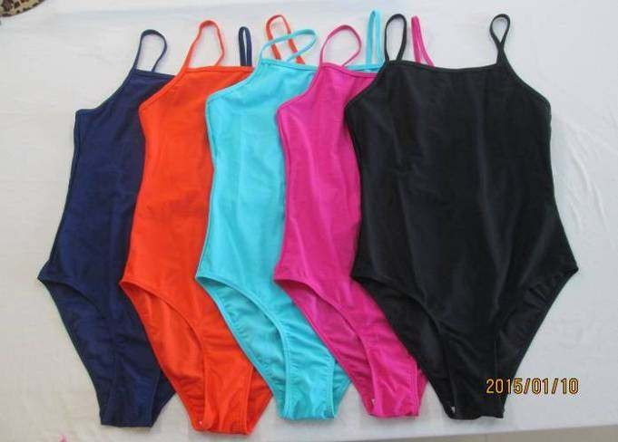
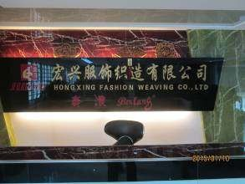 | 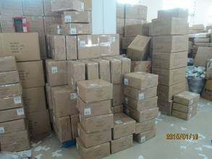
1 (1) 工厂/factory | 1 (2) 成品/carton stack
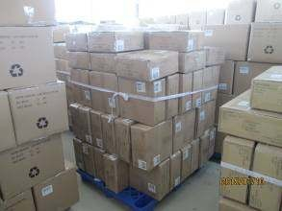 | 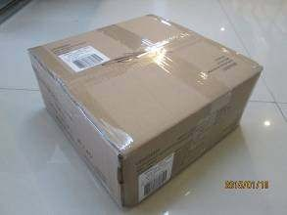
1 (3) carton stack | 1 (5) carton view
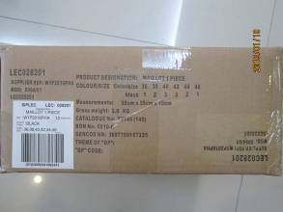 | 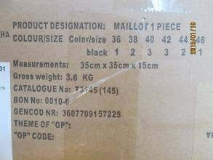
1 (6) side mark | 1 (7) side mark
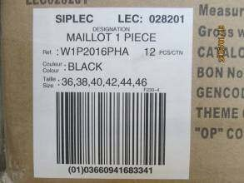 | 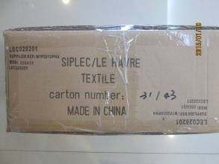
1 (8) carton label | 1 (9) shipping mark
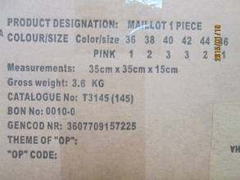 | 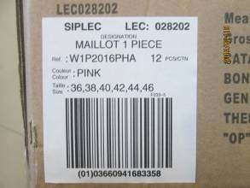
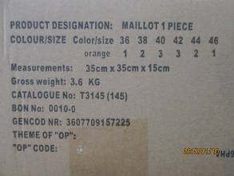 | 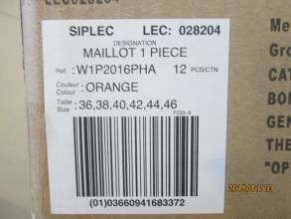
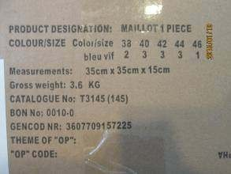 | 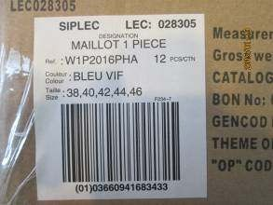
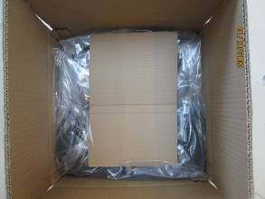
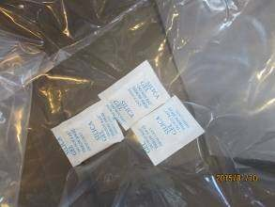 | 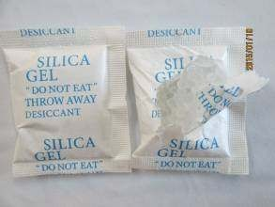
1 (52) silica gel | 1 (53) silica gel
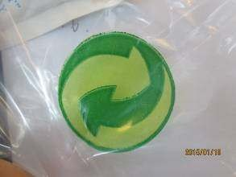 | 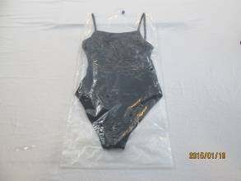
1 (54) recycle logo | 1 (55) product
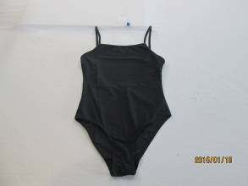 | 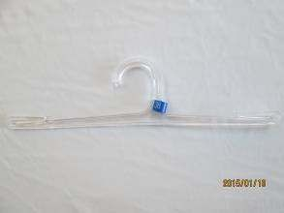
1 (56) product | 1 (57) hanger
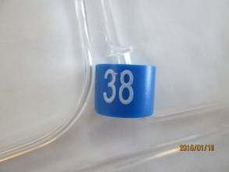 | 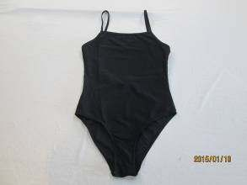
1 (58) size ring | 1 (59) product
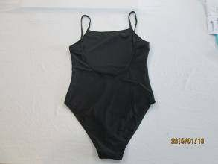 | 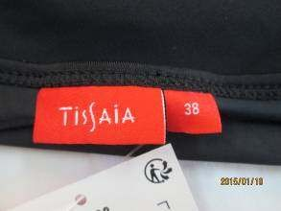
1 (60) product | 1 (61) main label
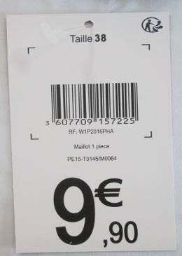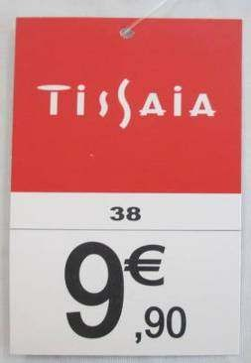
1 (63) hangtag | 1 (62) hangtag
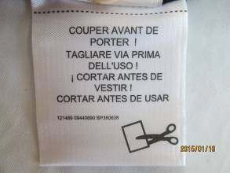 | 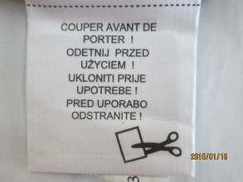
1 (65) alarm tag | 1 (64) alarm tag
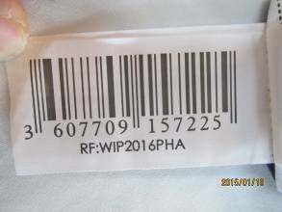 | 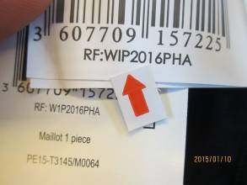
1 (66) barcode label | Found the description on barcode label was WIP2016PHA instead of Po spec. required  W1P2016PHA, but conform to ref. sample
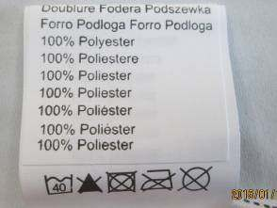 | 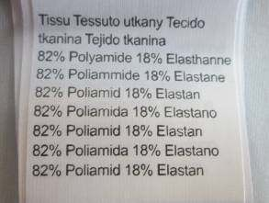
1 (67) label | 1 (68) label
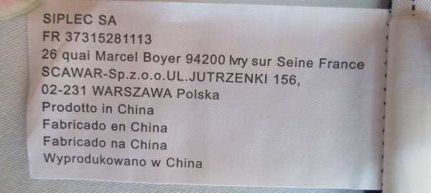
1 (69) care label
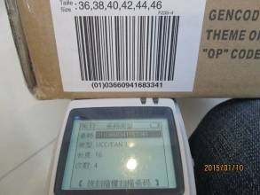 | 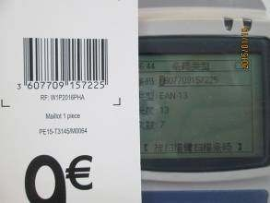
Barcode check | Barcode check
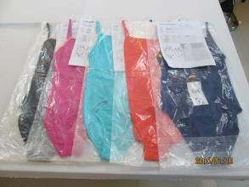 | 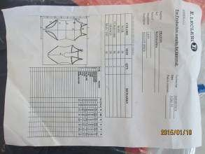
Ref. Sample | Ref. Sample Spec.
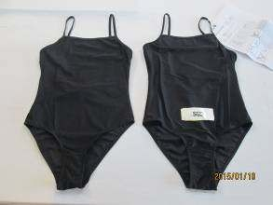 | 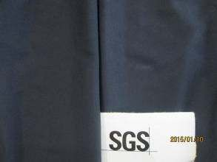
Product and ref. Sample | For color black, found the shell fabric was  darker than ref. Sample with grey scale 4-5
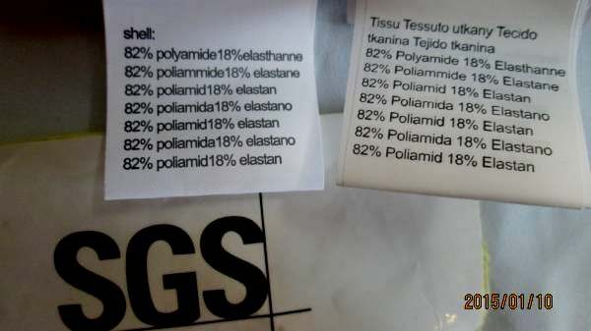
Found thed composition label not conform to ref. Sample
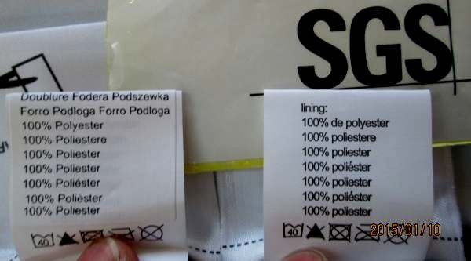
Found thed composition label not conform to ref. Sample
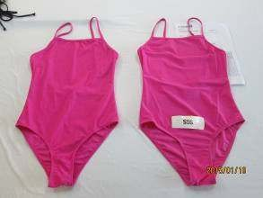 | 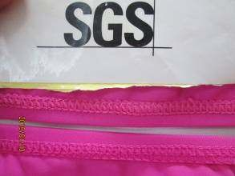
Product and ref. Sample | For color pink, found the sewn thread color wasd darker than ref. Sample with grey scale  4-5
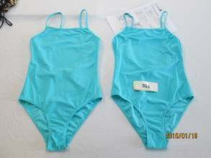 | 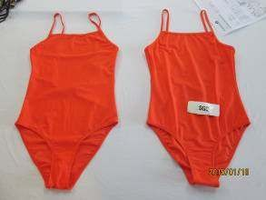
Product and ref. Sample | Product and ref. Sample
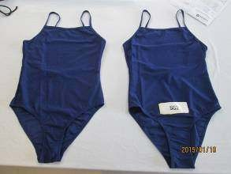 | 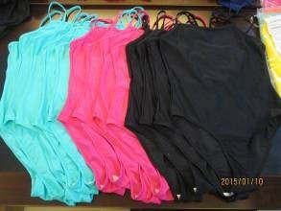
Product and ref. Sample | Color compare
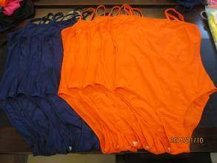 | 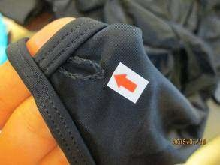
Color compare | Untrimmed thread ends-minor
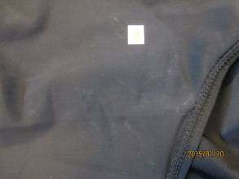 | 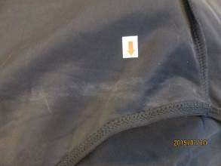
Dirty stain-minor | Dirty stain-major
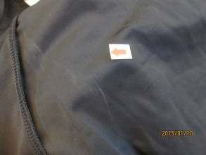
Dirty stain-minor | Dirty stain-minor
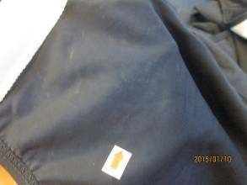 | 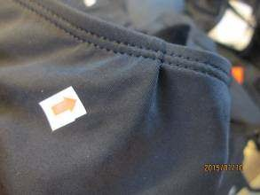
Dirty stain-minor | Pleat-major
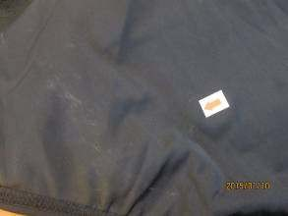 | 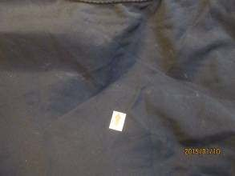
Dirty stain-minor | Dirty stain-major
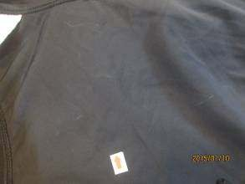 | 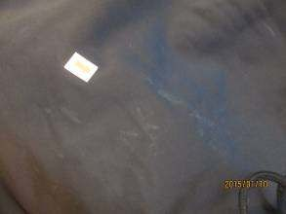
Dirty stain-minor | Dirty stain-minor
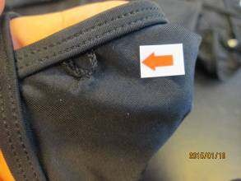 | 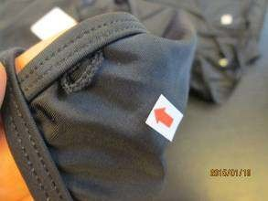
Untrimmed thread ends-minor | Untrimmed thread ends-minor
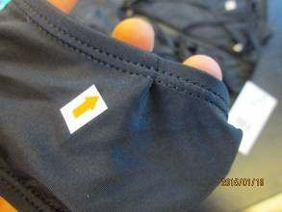 | 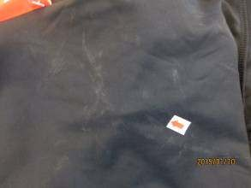
Pleat-major | Dirty stain-major
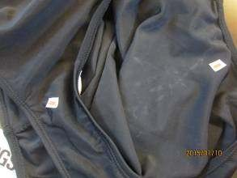 | 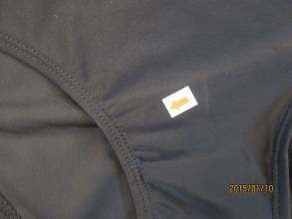
Dirty stain-major(also found pleat-major) | Puckering slightly -minor
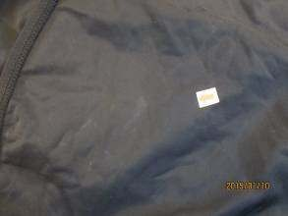 | 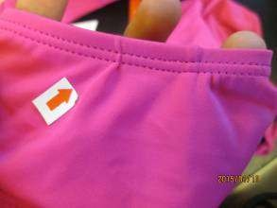
Dirty stain-minor | Pleat slightly –minor
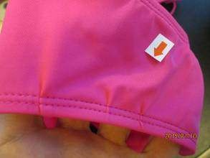 | 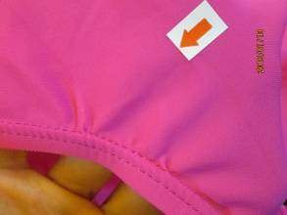
Pleat-major | Pleat-major
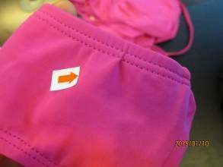 | 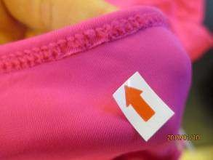
Pleat-major | Broken stitches-major
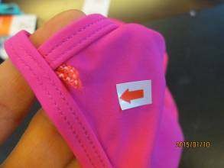 | 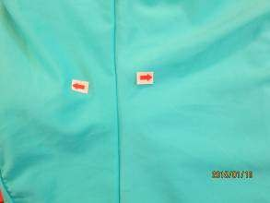
Untrimmed thread ends-minor | Color shade variation-major
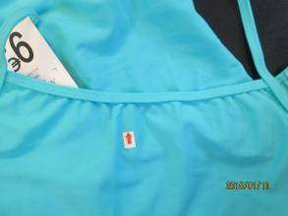 | 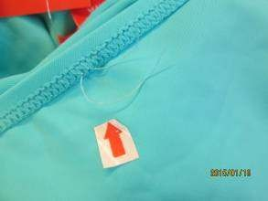
Puckering-major | Untrimmed thread ends-minor
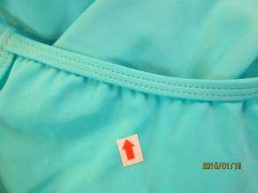 | 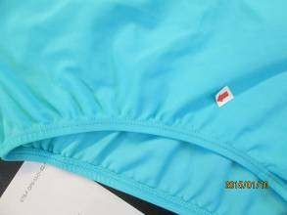
Puckering-major | Puckering-major
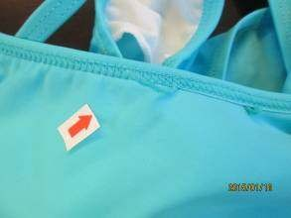 | 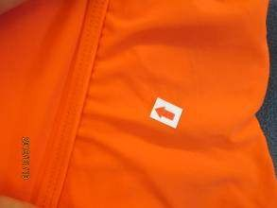
Untrimmed thread ends-minor | Puckering slightly –minor
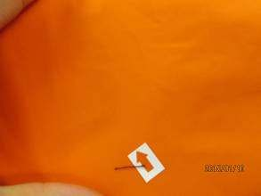 | 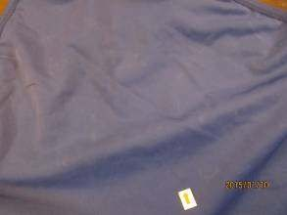
Dirty stain-major | Dirty stain-minor
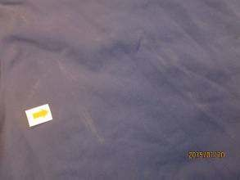 | 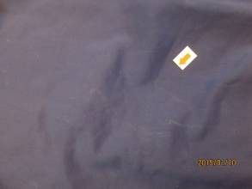
Dirty stain -major | Dirty stain -minor
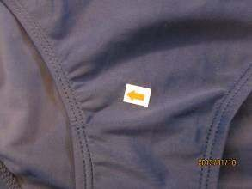 | 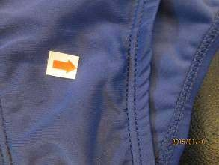
Puckering –major | Twisted –minor
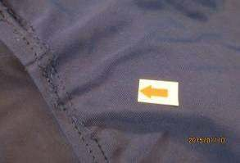 | 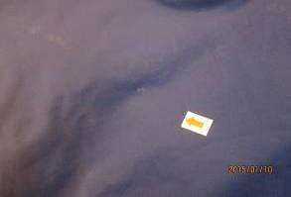
Broken stitches-major | Dirty stain-minor

